**lA LIST OF COMMANDS EXECUTED**

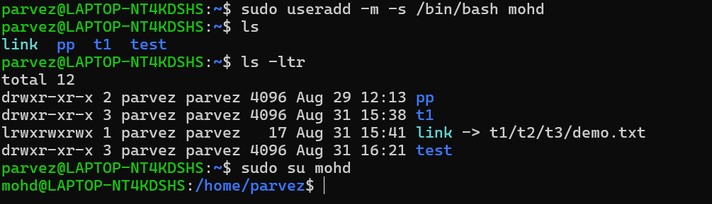

1. **Sudo -m -s /bin/bash mohd** – to create a new user.

* m → Creates a home directory (/home/newusername)
* -s /bin/bash → Sets the default shell to Bash
* New username → Replace with your desired username

**___________________________________________________________________________**

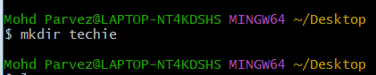

1. **mkdir** - create a new directory.

___________________________________________________________________________

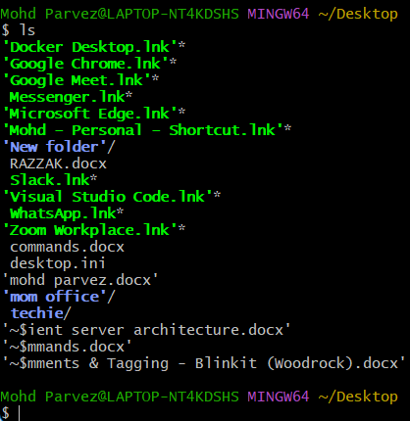

1. **ls -**  to list the the content of directory.

___________________________________________________________________________

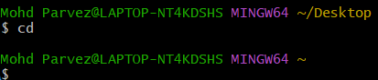

1. **cd** – change directory.

_____________________________________________________________________

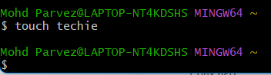

1. touch “ file name” – to create a empty file.

___________________________________________________________________________

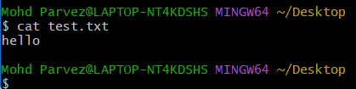

1. cat – to show contents of a file.

___________________________________________________________________________



1. rm – to delete the file

___________________________________________________________________________

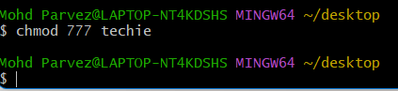

1. **chmod –** generarte or revoke permissions.

___________________________________________________________________________

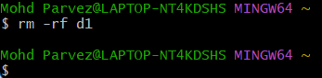

1. **rm -rf d1 :**  to delete the directory.

___________________________________________________________________________

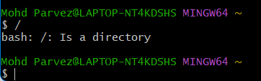

1. **/** : to show the root directory.

___________________________________________________________________________

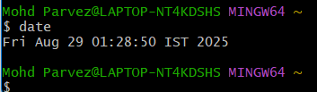

1. **date :**  to know date and time

__________________________________________________________________________________

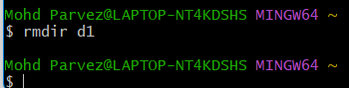

1. **rmdir :** to remove file name.

__________________________________________________________________________________

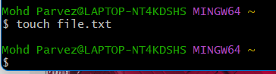

1. **touch file.txt :** to create an empty file.

__________________________________________________________________________________

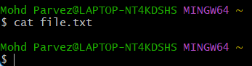

1. **Cat file.txt :** view contents of a file.

__________________________________________________________________________________

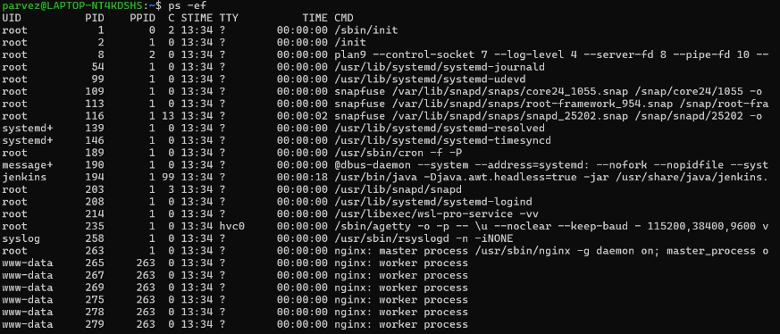

1. **ps -ef :** to know the system running process.

__________________________________________________________________________________

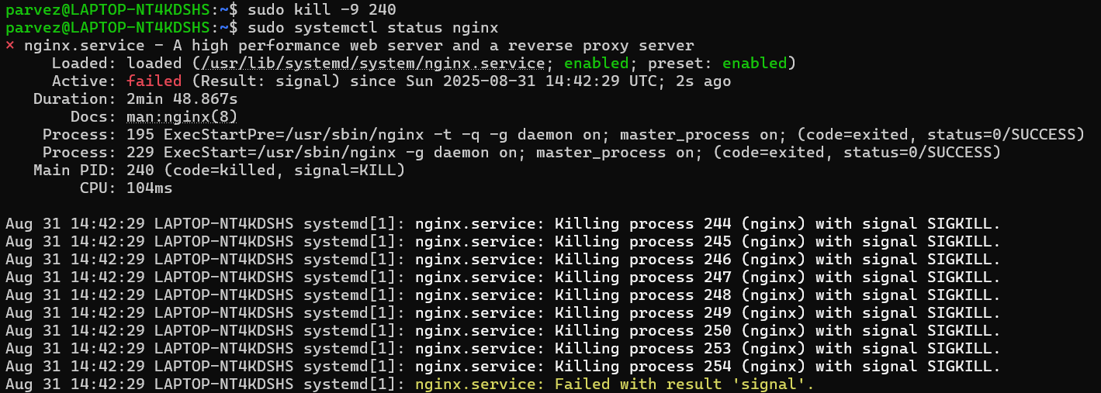

1. **sudo kill -9 “process name” :** Kill a running process.

_________________________________________________________________________________

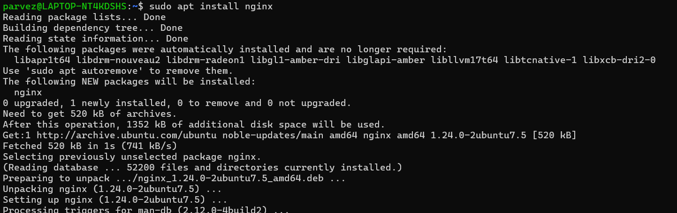

1. **sudo apt install nginx:** Install a package using the package manager (e.g., apt or yum).

___________________________________________________________________________

1. 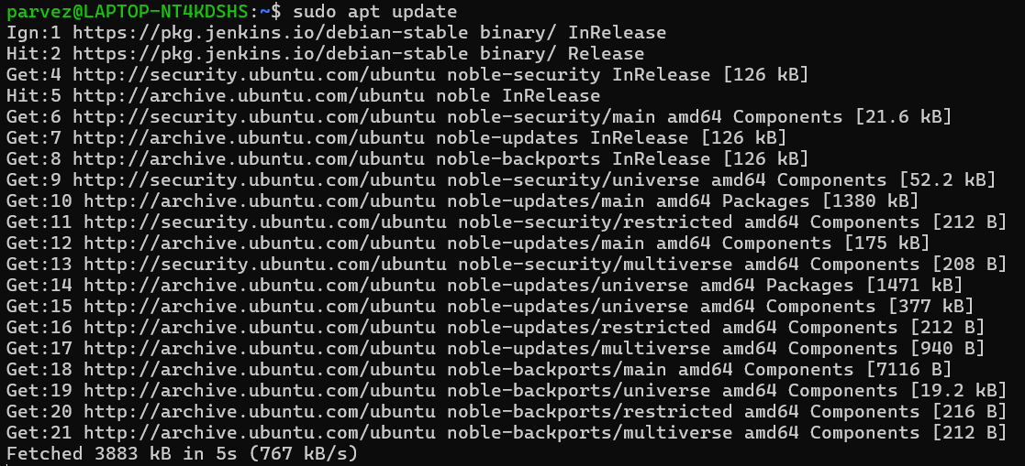**sudo apt update:** Update the system packages

___________________________________________________________________________

1. 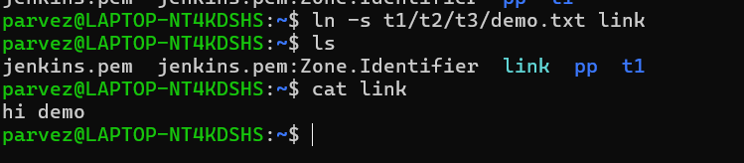 Ln -s :Create a symbolic link.

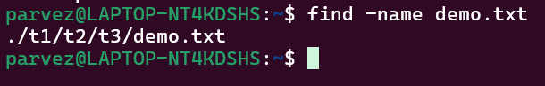________________________________________________________________________

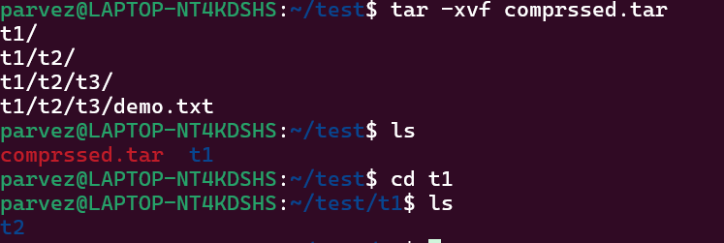 20. find -name demo.txt - Search for files using the find command.

___________________________________________________________________________

21. Compress and decompress files using tar.

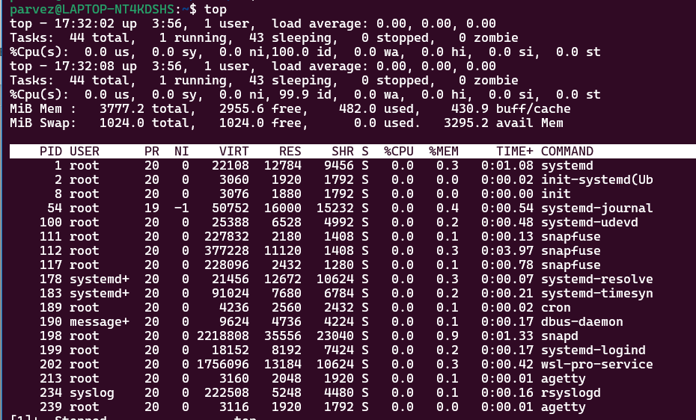  
22) Monitor system resources with top or htop.

23) C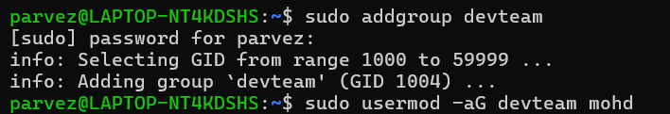

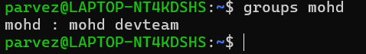  
23.) create and manage user groups.

* Sudo addgroup devteam – to add a user group
* Sudo usermod -aG devteam mohd – to add an existing user to group
* groups mohd – vie to which group it belongs to

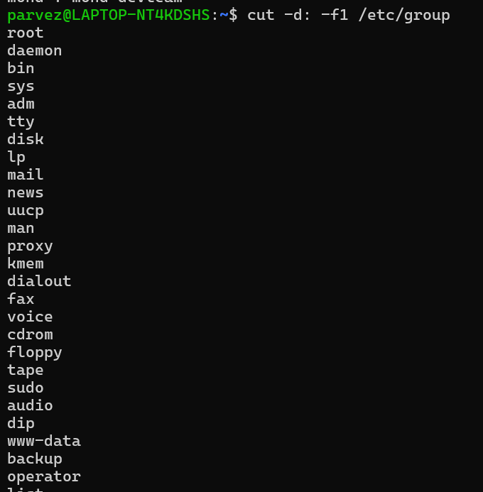

* cut -d: -f1 /etc/group - List all groups

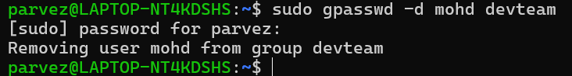

* sudo gpasswd -d mohd devteam – remove user from agroup

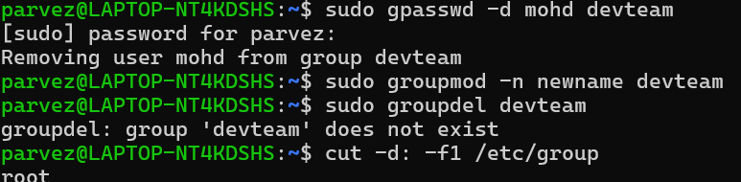

* sudo groupmod -n newname devteam - to change the group name
* sudo groupdel newname – to delete a group

___________________________________________________________________________

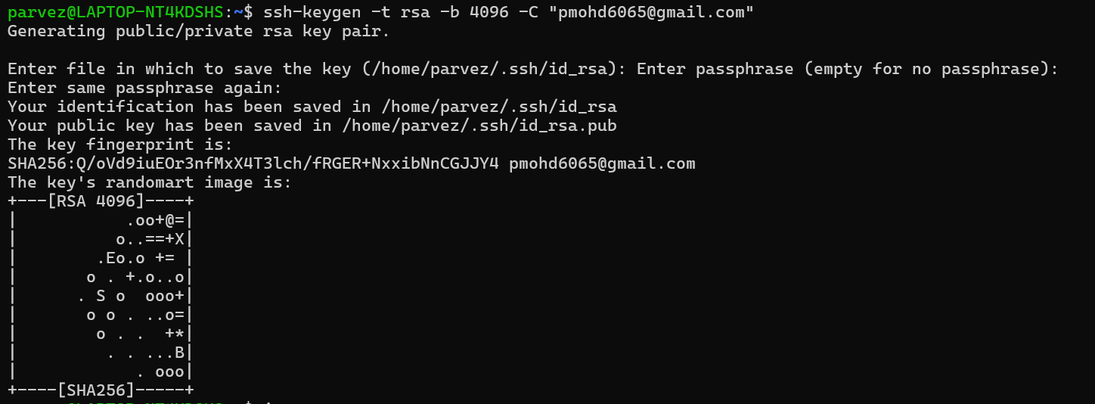

24) Set up SSH password less authentication. - ssh-keygen -t rsa -b 4096 -C “[your_email@example.com](mailto:your_email@example.com)”

___________________________________________________________________________

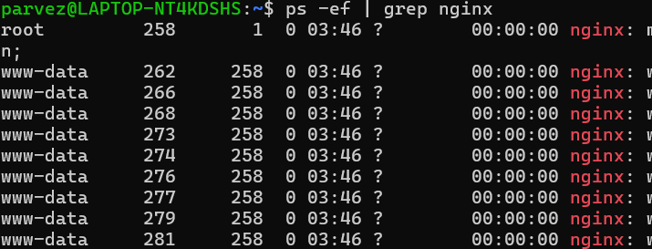

25) Monitor log files using tail : : grep. **Ps -ef | grep nginx**

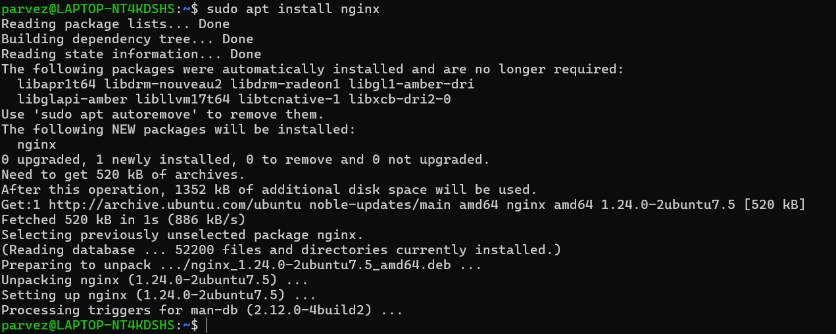  
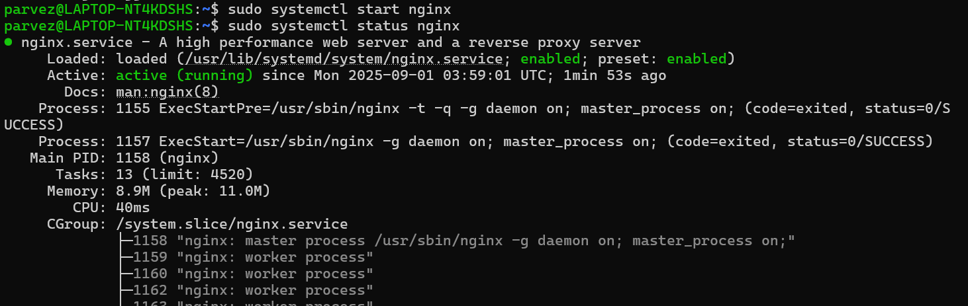

26) Set up a web server (e.g., Apache or Nginx).

**Sudo apt install nginx –** to install nginx service

**Sudo apt start nginx –**  to start nginx service.

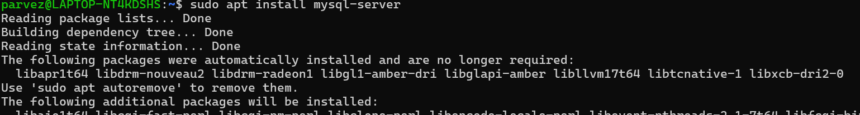  
27) Configure and secure a MySQL Database.

- Sudo apt install mysql-sever – This installs the MySQL server and client tools.

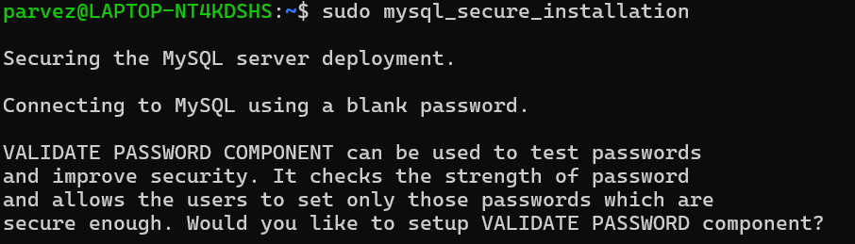



- sudo mysql_secure_installation : Run the built-in security script:

You’ll be prompted to:

Set root password

Remove anonymous users

Disallow remote root login

Remove test database

Reload privilege tables

Choose options based on your security needs.

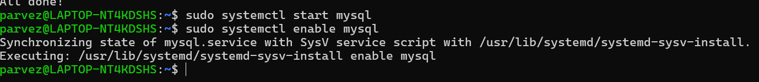

-sudo systemctl start mysql : start mysql server

-sudo systemctl enable mysql : enable the server

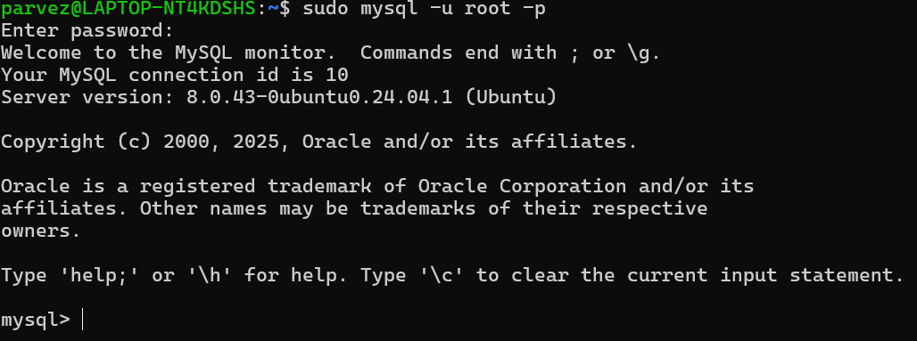

-**Log In to MySQL :** sudo mysql -u root -p

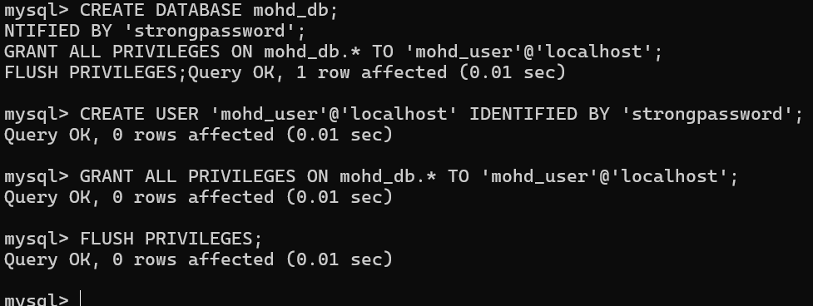**-** 

Create a Database and User Inside the MySQL shell:

CREATE DATABASE mohd_db;

CREATE USER 'mohd_user'@'localhost' IDENTIFIED BY 'strongpassword';

GRANT ALL PRIVILEGES ON mohd_db.* TO 'mohd_user'@'localhost';

FLUSH PRIVILEGES;

. **Configure Remote Access (Optional)**

Edit the config file:

sudo nano /etc/mysql/mysql.conf.d/mysqld.cnf

Change:

bind-address = 127.0.0.1

To:

bind-address = 0.0.0.0

Then restart MySQL:

sudo systemctl restart mysql

**Test Connection**

From another machine:

mysql -u mohd_user -p -h your_server_ip -D mohd_db

28) Set up a Application Server (e.g.,Apache Tomcat)

29) create a service file for Apache Tomcat.(Should execute by using systemtctl command)

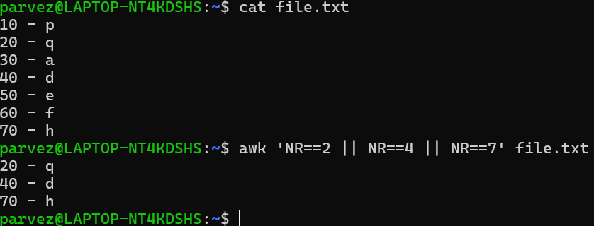

30) Print specific columns from a delimited file :

awk 'NR==2 || NR==4 || NR==7' filename.txt

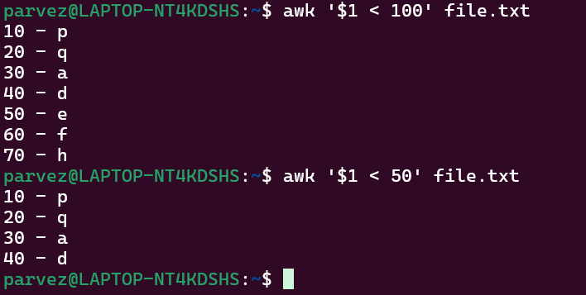

31) Filter and print lines based on a specific pattern or condition.

awk '$1 > 100' filename

  
32) Calculate and print the average, sum, or other statistics of a column.

awk '{sum += $2} END {print "Sum:", sum; print "Average:", sum/NR}' filename

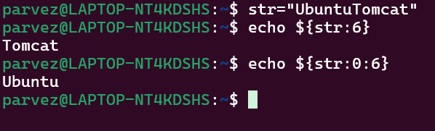  
33) Perform string manipulation, such as extracting substrings or changing case.

str="UbuntuTomcat"

echo ${str:6} # Output: Tomcat (from index 6 to end)

echo ${str:0:6} # Output: Ubuntu (first 6 characters)

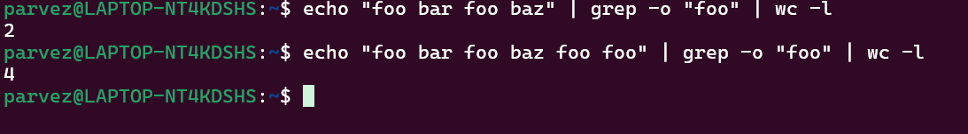  
34) Count the occurrences of a specific pattern in a file.

-o prints each match on a new line.

wc -l counts those lines = total matches.

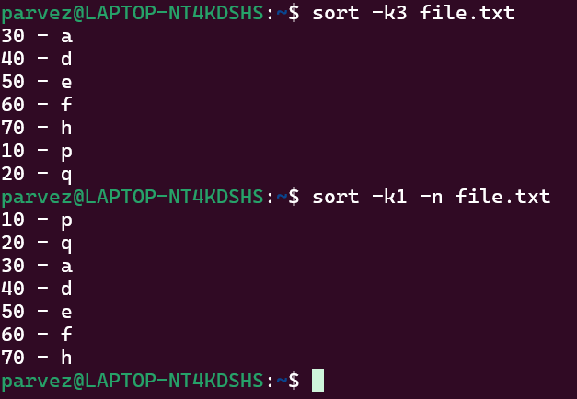  
35) Sort lines based on a specific field or column.

sort -k2 -n filename

Sorts by **column 2** numerically.

Use -n to treat values as numbers.

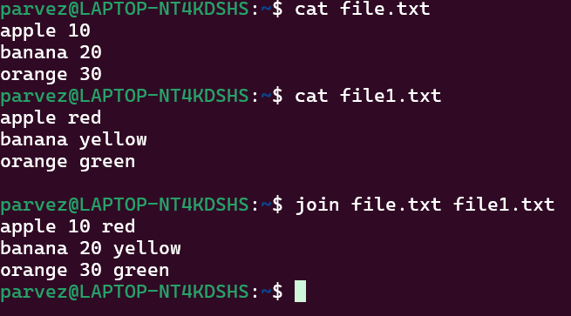  
36) Merge multiple files based on a common field or column.

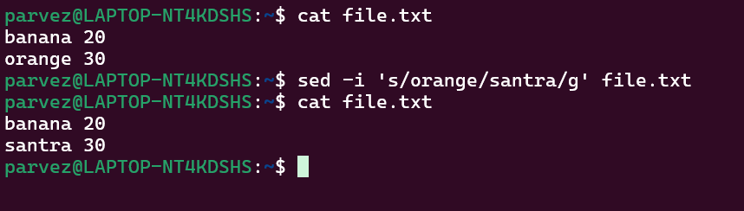  
37) Substitute text in a file using search and replace.

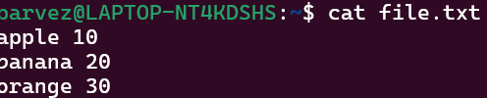

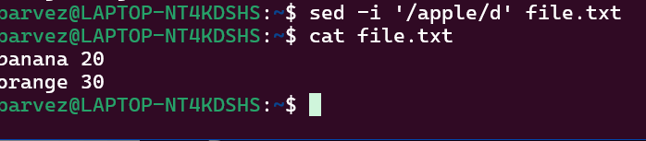  
38) Delete specific lines based on a pattern or line number.

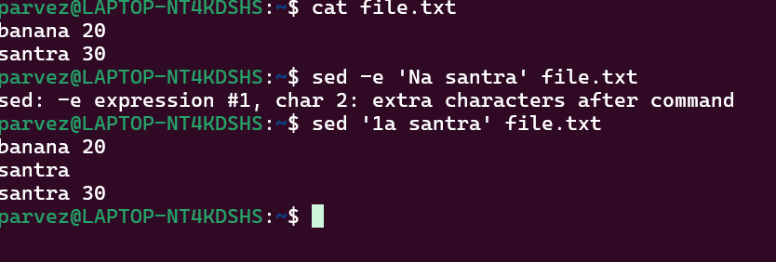  
39) Append or insert text before or after a specific pattern or line.

sed 'Na TEXT_TO_APPEND' filename.txt

Replace N with the line number and TEXT_TO_APPEND with the desired text. Insert before a specific line number.

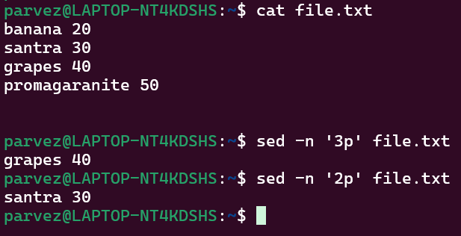  
40) Print only specific lines from a file.

sed -n '2p' filename.txt

41)  Copy file from linux to windows machine.

42)  5 use cases for AWK and 5 use cases for sed.



* awk '{print $1, $3}' data.txt – to extract specific coloums.
* awk ‘/error/ {print}’ : Filter Lines by Pattern, Find lines that match a keyword:

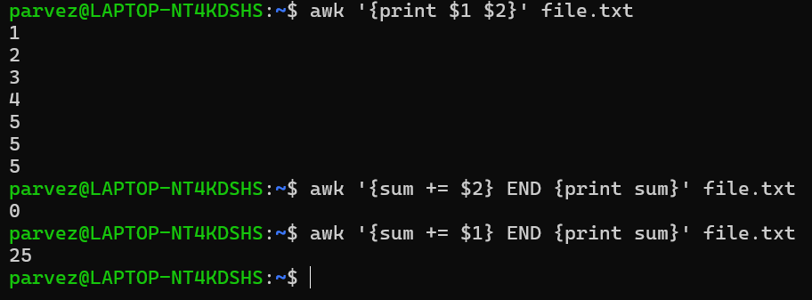

* awk ‘ {sum += $2} END {print sum}’ file.txt : Adds up all values in column .

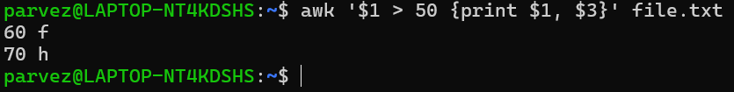

* awk ‘ $1 > 50 {print $1, $3}’ file.txt – Prints names and scores where the score is above 50